KIGSA GRAND PRIX CUPS 2024 PHOTO COMPETITION EYELASH MASTERS
2024.01.31.
REGISTRATION FORM
The registration deadline is January 1, 2024
Filled registration form together with the photos must be emailed to info@kigsa.lt
The registration fee is payed to this bank account:
BENEFICIARY | Kirpėjų ir grožio specialistų asociacija  LT867300020115667128
 | AB Swedbank
NAME AND ADDRESS OF BENEFICIARY BANK’S CORRESPONDENT | Name and surname , and the categoriesof eyelashextentions you will be participating
PAYMENT DETAILS

Registration is confirmed after receiving the payment. You will be contacted personally.
Participant's name, surname......................................................................................................................................................................…
City, address: ……………………………………………………………………………………………………......................................................
Salon: ………………………………………………………………………………………………………………...................................................
Phone number:……………………………………………………………………………………………………………...........................................
E-mail:............................................................................................................................................................................................................
Traine’s name, surname...........………………………………………………………………………………….....................................................
Category | Members of KIGSA (Association of hairdressers and beauty professionals) | Not members of KIGSA (Association of hairdressers and beauty professionals)
□ □ Classic Eyelash Extensions  ○JUNIOR  ○MASTER | 40 € | 50 €
Volume 2-7D Eyelash Extensions  ○JUNIOR  ○MASTER | 40 € | 50 €
□ Lash Lamination  ○JUNIOR  ○MASTER | 40 € | 50 €
In total:

*ATTENTION! It is necessary to mark your category. Price for participating in two categories: Members of KIGSA - 70 €, Not members of KIGSA - 80 €. Price for participating in three categories: Members of KIGSA - 105 €, Not members of KIGSA – 115 €.

Date .............................. Participant‘s signature.................................

CONDITIONS OF THE PHOTO CONTEST:

- EYELASH EXTENSION NOMINATIONS. Participants of the contest have to send 4 photos and 2 videos of working process for selected nomination.
-BEFORE PROCEDURE
1. Model looks straight into the camera at a distance of 20-30 cm.

-AFTER PROCEDURE
2. Model looks straight into the camera at a distance of 20-30 cm.
3. One eye looks up.
4. Model with eyes closed at a distance of 20cm, with eye patches and lash mapping. The photo is taken from behind of the model head while lying down.
*The particular creteria will be evaluated from each photo. If some of the required photos are not sent, it will be impossible to get the maximum number of points.
5. Close-up video of the left eye open (recommended with a lens or macro mode) so that the entire lash line, outer and inner corners could be clearly seen.
6. Close-up video of the right eye open (recommended with a lens or macro mode) so that the entire lash line, outer and inner corners could be clearly seen.

- LASH LAMINATION NOMINATION. Participants of the contest have to send 10 photos and 2 videos of working process for Lash lamination nomination.
-BEFORE PROCEDURE
1. Model looks straight into the camera at a distance of 20-30 cm, full face should be visible.
2. Model sits or stands with eyes open from the side to see the curl of natural lashes.
3. Photos with the MACRO lens for each eye separately, the angle is straight.

-PROCESS
4. Lashes of both eyes lifted on the silicone curler. The size of the silicone curler must be clearly seen in the photo.

-AFTER PROCEDURE
5. Model looks straight into the camera at a distance of 20-30 cm.
6. Photos with the MACRO lens for each eye separately, the angle is straight.
*The particular creteria will be evaluated from each photo. If some of the required photos are not sent, it will be impossible to get the maximum number of points.
7. Close-up video of the left eye open (recommended with a lens or macro mode) so that the entire lash line, outer and inner corners could be clearly seen.
8. Close-up video of the right eye open (recommended with a lens or macro mode) so that the entire lash line, outer and inner corners could be clearly seen.

- Montages (collages) made from 2 or more photos are not allowed!
- MODEL MUST be wearing a white T-shirt without any logos, hair in a bun or ponytail.
- Photos of work must be new, taken particularly for this competition. Moreover, they cannot be published before and during the competition, until the results are officially published.
- Watermarks, logos or personal details on photos are not allowed.
- If this condition of the competition is violated - the registration will be canceled and the participation fee will not be refunded!
- Photo requirements:
1. The photo should be in digital format as high quality as possible.
2. In high resolution to make the details clear.
3. The photo may be slightly edited in Photoshop or another program, but it cannot be changed, adjusted, or drawn in the eyelash extension area. * *if the photo is edited, it is necessary to add the original one as well, moreover, the edited one must be marked with a note "photo retouched".
4. The background of photos is recommended to be white or black.
- The organizers of competition have the right to use photos at any public space without a separate permission of the participants and models in the photos.
- Photos together with the filled registration form must be emailed to info@kigsa.lt until 2024 january 1

CATEGORIES:

- JUNIOR - Less than 2 years’ experience
- MASTER - More than 2 years’ experience
- EXPERT-From 5 years.Working master, trainer or multiple winner of online, live championships
- * Participants must send a copy of the first diploma as proof of one‘s experience and permition to compete in a particular category.
NOMINATIONS

CLASSIC EYELASH EXTENSIONS – 1:1 eyelash extensions, when one artificial lash is applied on one natural lash. Harmony on the face as well as maximum naturalness is maintained according to the following rules:

- Thickness of 0.07, 0.08, 0.10 or 0.12 mm may be used in Classic Eyelash Extensions.
- Color of eyelash extensions is either black or brown, in accordance with the color of model’s skin and hair.
- Curls as B, C, J, CC, D, L, M, V, U, L+, LC, LD, etc. may be used.
- Clear adhesive are recommended for brown extensions.
- Not less than two curls must be used for a particular effect/style.
- It is necessary to work with lash layers.
- Length chosen should be the same as model’s natural lashes or 2 mm longer.
- Model’s face may be easily contoured, with pink cheeks, drawn eyebrows, lips applied with colorless lip gloss. However, the model cannot be with permanent or cosmetic makeup in the eye area.
- Shiny or any other accessories are not allowed.
- Eyelash extensions must be neat and clean. The eyes of the model cannot be red after the procedure. There should be no traces of gel of the eye pads, no pen or glue marks on the skin, also no adhesive excess or whitening on the lashes. No cosmetic residue or other dirt in the eye area.
- Coverage of eyelashes must be 100 per cent (every natural lash is covered both in the inner and outer corners of the eyelid and in the central part of the eye).
- Distance from the eyelid is 0.2 – 0.4 mm (if distance chosen is 0.4 mm, it must be maintained the same distance through the whole lash line.
- Eyelash extensions are applied on a live model!

VOLUME 2-7 D EYELASH EXTENSIONS - Eyelash extensions that complement model’s eyes and face features while using appropriate effect, curls, lengths and thickness.. Harmony on the face is maintained according to the following rules:

- Thickness of 0.03, 0.05, 0.06 or 0.07 mm may be used in Volume Eyelash Extensions. The volume type is chosen by the master (if the technique chosen is 5D, the whole eyelash extension must be done only in Volume 5D).
- Curls as B, C, J, CC, D, L, M, V, U, L+, LC, LD, etc. may be used.
- Volume extensions must be done in a clear solid line, such styles as "Kim k, Kylie style, Wet lashes" and other are not allowed for this category.
- It is forbidden to use pre-made fans.
- Color of eyelash extensions is either black or brown, in accordance with the color of model’s skin and hair.
- Clear adhesive are recommended for brown extensions.
- No less than two curls must be used for a particular effect/style.
- It is necessary to work with lash layers.
- Length chosen should be the same as model’s natural lashes or 2 mm longer.
- Model’s face may be easily contoured, with pink cheeks, drawn eyebrows, lips applied with colorless lip gloss. However, the model cannot be with permanent or cosmetic makeup in the eye area.
- Shiny or any other accessories are not allowed.
- Eyelash extensions must be neat and clean. The eyes of the model cannot be red after the procedure. There should be no traces of gel of the eye pads, no pen or glue marks on the skin, also no adhesive excess or whitening on the lashes. No cosmetic residue or other dirt in the eye area.
- Coverage of eyelashes must be 100 per cent (every natural lash is covered both in the inner and outer corners of the eyelid and in the central part of the eye).
- Distance from the eyelid is 0.2 – 0.4 mm (if distance chosen is 0.4 mm, it must be maintained the same distance through the whole lash line.
- Eyelash extensions are applied on a live model!

LASH LAMINATION - taking into account the shape of the eyes and face of the model, the appropriate lash lifting effect is selected.
- General look. Attention is drawn to all the criteria at the same time, the correct curl of the lashes, and the symmetry of both eyes.
- Lash lamination should be done correctly so that natural lashes do not touch the upper eyelid.
- Size and form of silicone curler must be chosen according to model’s eyes: deep-set eyes, drooping eyelid, lowered outer corners of the eye.
- Both eyes should be the same. Natural eyelashes laminated evenly.
- Perfect lifting. All natural lashes should be well lifted in the root zone, especially in the inner and outer corners. The eyelash in the root zone cannot be broken.
- Lash curl in one plane. All layers of natural eyelashes must be in one clear line, the placement of eyelashes even. The tips are not broken.
- Natural lashes must be laminated in the correct direction, lined up evenly to one another without crisscrossing or visible spaces.
- All layers of natural lashes should be in one even line. There should be no wavy lashes, broken ends.
- Products application technique is chosen according to the shape of model’s eyes.
- Natural eyelashes may be tinted with blue-black, black, brown or grey color. It depends on model’s skin type and hair color. Event, smooth distribution of the tint.

EXAMPLES
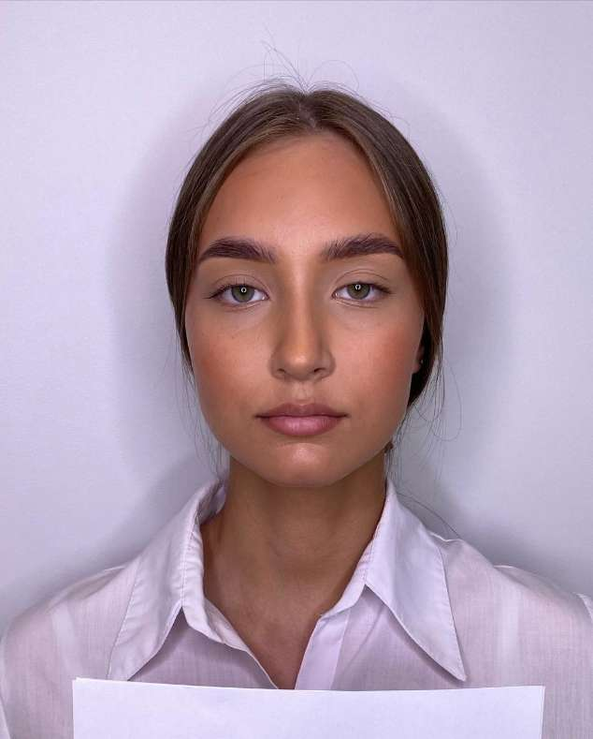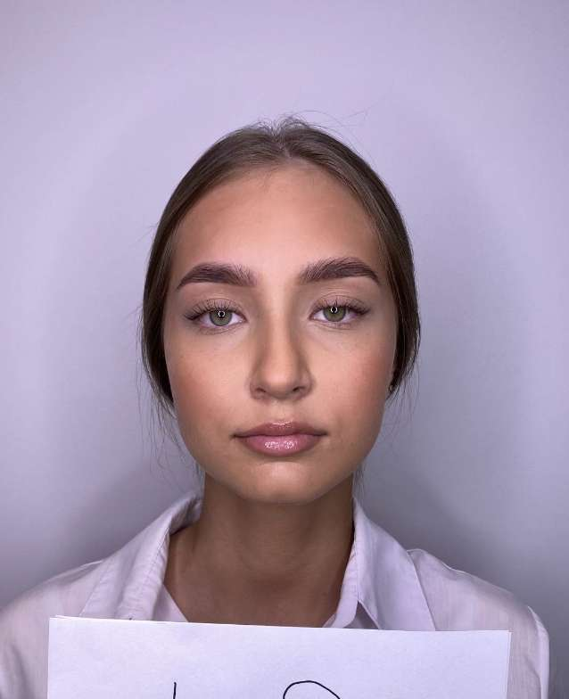
- 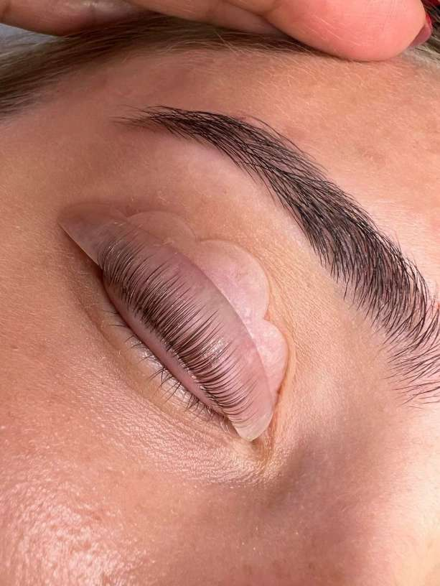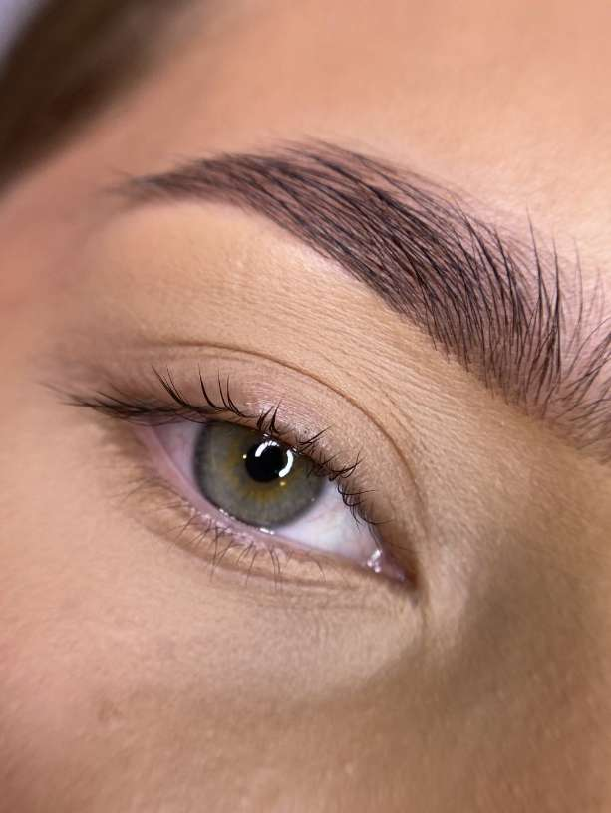
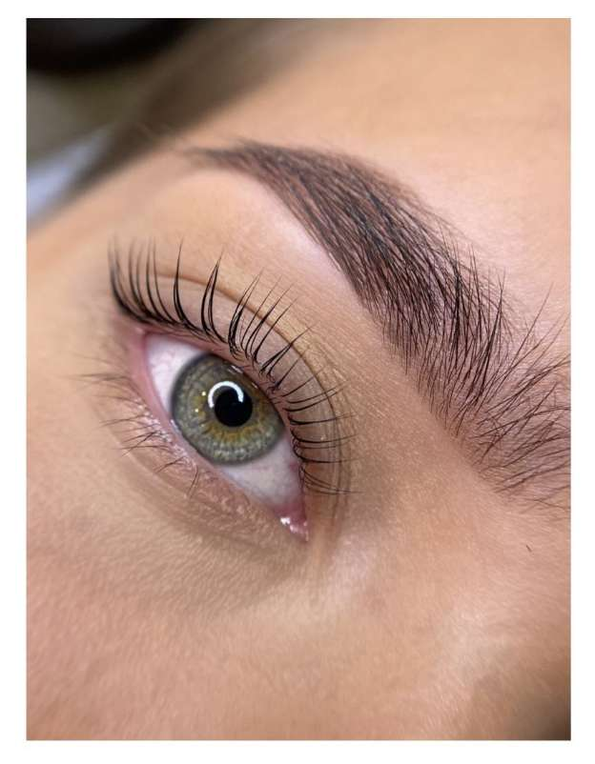
- The concentrate applied at the end (No. 3, etc.) must not weigh down and stick together the natural eyelashes.
- Model’s face may be easily contoured, with pink cheeks, drawn eyebrows, lips applied with colorless lip gloss. However, the model cannot be with permanent or cosmetic makeup in the eye area.
- After the lash lamination procedure natural eyelashes must be clean, fluffy, there should be no tint left on the skin or natural eyelashes.
- Eyelash extensions are applied on a live model!

Evaluation and Awards:
• The evaluation committee of the tender works will be made up of internationally recognized foreign and domestic professionals.
• After summing up the votes of the commission, from each category of the competition, the three authors of the works with the most votes will be selected and awarded, if the same number of points are collected, two prize places will be awarded.
• From the winners of all categories, only one craftsman will be selected and awarded, having collected the most votes by participating in at least two categories of the competition.
• The winner will be awarded the Kigsa Grand prix cup and a cash prize of 200 eu.
• The participants of the photo contest for 4-5 places will also be awarded.
• All participants will receive participant diplomas for their participation. All works will be exhibited on the Facebook and Instagram accounts of the association.

