LITHUANIA OPEN CHAMPIONSHIP (LAČ)
"KAUNAS BEAUTY 2024"
24-25 February 2024

EYEBROW DESIGN SECTOR COMPETITIONS

- Eyebrow shaping and colouring competition according to OMC rules (juniors, masters)
- Eyebrow lamination and colouring competition (juniors, masters)
- Men's eyebrow correction and colouring competition (juniors, masters)

* The organizers of the contest reserve the right to cancel or postpone any competition at their sole discretion. If less than 3 participants take part in an competition, the competition will be cancelled. Participants will be informed of the decision after the official closing date for registration and in the competition of cancellation registration fees for these competitions will be refunded.

GENERAL PROVISIONS
1. REGISTRATION CONDITIONS
Competition participant must meet the following criteria:
- Master - a beauty professional who has worked in the field for more than 1 (one) year;
- Junior- a beauty professional who has worked in the field for up to 1 (one) year;
- Student - beauty professional in training (no age limit, student ID required);

An unlimited number of participants can register for the competition. The age of the participants is not limited.
The registration form must be filled in, signed and sent to the address: Ariogalos g. 40, LT-48337 Kaunas or by e-mail info@kigsa.lt .
The deadline for registration is 1 February 2024.
Registration is open and fees are accepted from individuals wishing to participate in the competition or from the organisations they represent.
If fewer than 3 entries are registered for a particular category on the day of the registration deadline, such competition may be cancelled at the decision of the organisers.

2. PARTICIPATION FEE
The entry fee is only payable for the competition in which you participate. The entry fee can be paid by bank transfer to the Association of Hairdressers and Beauty Professionals a.s. LT86 7300 0101 1566 7128, AB Swedbank. Please indicate the name and surname of the participant in the payment purpose. Registration fees will not be accepted at the competition.
Competitors wishing to register after the registration deadline must pay an additional 25% fee.

3. THE SCHEDULE
All competitors must be in the dressing room at least 30 minutes before the start of the competition.
Only for justified reasons, additional time will be granted to late entrants (up to the total time allocated for the task).
No additional time will be granted to tenderers who are late in starting their tender work without a justifiable reason.

4. CANCELLATION OR POSTPONEMENT OF COMPETITIONS
The organisers of the Championships reserve the right to cancel or reschedule any competition at their discretion. If less than 3 competitors are registered for an competition, the competition will be cancelled.
Competitors will be informed of the decision to cancel or reschedule an competition after the official closing date for registration and, in the competition of a cancellation, the registration fees for these competitions will be refunded.

5. OBSERVERS
During the championship, the work of the competitors is supervised by observers, who monitor the work process and record infringements, which are reported to the Chief Commissioner at the end of the competition, who applies a penalty point system.

6. THE JUDGES' DECISION
The decision of the judges is final and irrevocable.
GENERAL RULES

1. Participants will be informed of the mirror numbers 20 minutes before the start of the competition. Participants must be at their workstations at least 15 minutes before the announced start time. The Chairman of the Jury shall check that the mirror numbers match the names of the participants.
2. Models are not allowed to assist participants. Penalty points will be awarded for this.
3. Models must sit or stand facing the judges when judging the works.
4. Once the participants have completed their works, the judges will only pass through the room once to get a general impression.
5. In a second passage through the hall, the judges evaluate the works according to the criteria set.
6. Violations of the Competition Rules and non-compliance with the Rules will be penalised in accordance with the applicable penalty points system.
7. Penalty points. The minimum penalty shall be 5 penalty points per infringement.
8. Measures. The use of any unauthorised means shall be penalised.
9. Disqualification: if a competitor exchanges mirror numbers with another competitor.
10. When the participants have finished their work (at the final signal), they have 3 minutes to tidy up their work area (no tools or other objects may be left on the work table), prepare (plant or place) the model for judging and leave the competition area. During this additional time, the model's face must not be touched.
Participants must be familiar with the General Rules and comply with them.

WOMEN'S INDIVIDUAL-TECHNICAL CATEGORY. MASTERS COMPETITION.
Eyebrow shaping and colouring competition according to OMC rules

Women's individual competition, live model
No age limit for participants
Participants bring their models to the competition site with their hair neatly tied up. Models must not have permanent make-up (tattoos) on all areas of the face and must not have eyelash extensions. Models must wear a plain white (no drawings, no embellishments, no sponsor logos) waist-length T-shirt, black trousers or skirts long enough to cover the knees and black shoes. Models who do not comply with these instructions will not be admitted to the competition site.

Hygiene requirements must be observed.
Participants must be familiar with the General Rules and comply with them.

- Allowed: face preparation, light contouring or blushing, black mascara, natural lip pencil and colourless lip gloss. Eyebrows must look natural and must not have been shaped or coloured in the two weeks prior to the competition.
- Eyebrow restoration or extension products are not allowed, and working with henna eyebrow dyes is strictly prohibited. The use of chemical cream or gel eyebrow colours and the use of a liner are compulsory.
- Model make-up and preparation requirements: the model must be prepared before the competition (see Annex 1).
- Bright accessories are prohibited.
- Classical method of shaping: only tweezers must be used.
- Eyebrows must be tinted only with the eyebrow shade. Natural shades are allowed. Eyebrow pencils may be used during shaping and tinting, but the final work must be submitted without any eyebrow colour, cosmetics other than clear eyebrow gel or clear eyebrow wax. The use of foundation or concealer to cover redness of the skin is allowed.
- Photo: participants must bring a portrait photo of the model (A4, full-face, glossy) to be placed at the participant's workstation: before the eyebrow shaping and colouring exercise.
- Before the competition starts, the observers check that the photos on the table match the model's appearance. A sample photo is attached.
- Participants are allowed to: bring your own high chair and additional lighting.
- Evaluation criteria:
  - general 'before' and 'after' view of the model A4 FORMAT TYPE PHOTOGRAPH WHICH SHALL BE ON THE PARTICIPANT'S WORK TABLE;
  - symmetry and harmony of the shape of the eyebrows in relation to the shape of the model's face;
  - choice of colours and harmonious eyebrow colour;
  - removal of eyebrow hairs behind the shape.
- Time: 30 min.
12. Rating: max. 30 points, min. 21 points
13. Penalty points: entrants who do not comply with the rules of the competition will be penalised according to a penalty point system (5 points for 1 infringement).
WOMEN'S INDIVIDUAL-TECHNICAL CATEGORY. MASTERS COMPETITION.
Eyebrow Lamination and Colouring Challenge

Women's individual competition, live model
No age limit for participants
Participants bring their models to the competition site with their hair neatly tied up. Models must not have permanent make-up (tattoos) on all areas of the face and must not have eyelash extensions. Models must wear a plain white (no drawings, no embellishments, no sponsor logos) waist-length t-shirt, black trousers or skirts long enough to cover the knees and black shoes. Models who do not comply with these instructions will not be admitted to the contest site.

Hygiene requirements must be observed.
Participants must be familiar with the General Rules and comply with them.

- Allowed: face preparation, light contouring or blushing, black mascara, natural lip pencil and colourless lip gloss. Eyebrows must look natural and must not have been shaped or coloured in the two weeks prior to the competition.
- Eyebrow restoration or extension products are not allowed, and working with henna eyebrows is strictly prohibited. The use of chemical cream or gel eyebrow colours and the use of a liner are compulsory.
- Model make-up and preparation requirements: the model must be prepared before the competition (see Annex 1).
- Bright accessories are prohibited.
- Shaping method: all shaping methods (tweezers, wax, thread) can be used.
- Eyebrows must be tinted only with the eyebrow shade. Natural shades are allowed. Eyebrow pencils may be used during shaping and tinting, but the final work must be submitted without any eyebrow colour, cosmetics other than clear eyebrow gel or clear eyebrow wax. The use of foundation or concealer to cover redness of the skin is allowed.
- Eyebrow lamination and colouring must be carried out, and the arc of hair placement, symmetry, straightness of the hair, and cleanliness of the instruments must be assessed.
- Photo: participants must bring a portrait photo of the model (A4, full-face, glossy) to be placed at the participant's workstation: before the eyebrow shaping and colouring exercise.
- Before the competition starts, the observers check that the photos on the table match the model's appearance. A sample photo is attached.
- Participants are allowed to: bring your own high chair and additional lighting.
- Evaluation criteria:
  - general 'before' and 'after' view of the model A4 FORMAT TYPE PHOTOGRAPH WHICH SHALL BE ON THE PARTICIPANT'S WORKING TABLE;
  - symmetry and harmony of the shape of the eyebrows in relation to the shape of the model's face;
  - choice of colours and harmonious eyebrow colour;
  - removal of eyebrow hairs behind the shape.
- Time: 60 min.
13. Rating: max. 30 points, min. 21 points
14. Penalty points: entrants who do not comply with the rules of the competition will be penalised according to a penalty point system (5 points for 1 infringement).

MEN'S TECHNICAL CATEGORY. MASTERS.
Men's eyebrow correction and colouring competition

Live model
No age limit for participants
Participants bring their models to the competition site with neatly combed hair. Models must wear a plain white (no drawings, no decorations, no sponsors' logos) waist-covered T-shirt, black trousers and black shoes. Models who do not comply with these instructions will not be admitted to the contest site.

Hygiene requirements must be observed.
Participants must be familiar with the General Rules and comply with them.

- Allowed: face preparation, light masculine contouring. lip balm. Eyebrows must look natural and must not have been shaped or coloured for two weeks prior to the competition.
- Eyebrow restoration or extension products are not allowed, and working with henna eyebrow dyes is strictly prohibited. The use of chemical cream or gel eyebrow colours and the use of a liner are compulsory.
- Model make-up and preparation requirements: the model must be prepared before the competition (see Annex 1).
- Bright accessories are prohibited.
- Shaping method: all shaping methods (tweezers, wax, thread) can be used.
- Eyebrows must be tinted only with the eyebrow shade. Natural shades are allowed. Eyebrow pencils may be used during shaping and tinting, but the final work must be submitted without any eyebrow colour, cosmetics other than clear eyebrow gel or clear eyebrow wax. The use of foundation or concealer to cover redness of the skin is allowed.
- Photo: participants must bring a portrait photo of the model (A4, full-face, glossy) to be placed at the participant's workstation: before the eyebrow correction and colouring exercise.
- Before the competition starts, the observers check that the photos on the table match the model's appearance. A sample photo is attached.
- Participants are allowed to: bring your own high chair and additional lighting.
- Assessment. The conformity of the male eyebrow shape to the facial features and proportions, the cleanliness of the dye from the skin, the natural shade of the dyed hair will be assessed. Assessment criteria:
  - general 'before' and 'after' view of the model A4 FORMAT TYPE PHOTOGRAPH WHICH SHALL BE ON THE PARTICIPANT'S WORK TABLE;
  - symmetry and harmony of the shape of the eyebrows in relation to the shape of the model's face;
  - choice of colours and harmonious eyebrow colour;
  - removal of eyebrow hairs behind the shape.
- Time: 30 min.
- Rating: max. 30 points, min. 21 points
- Penalty points: entrants who do not comply with the rules of the competition will be penalised according to a penalty point system (5 points for 1 infringement).

ANNEX 1. Model make-up and preparation requirements (model must be prepared before the competition)

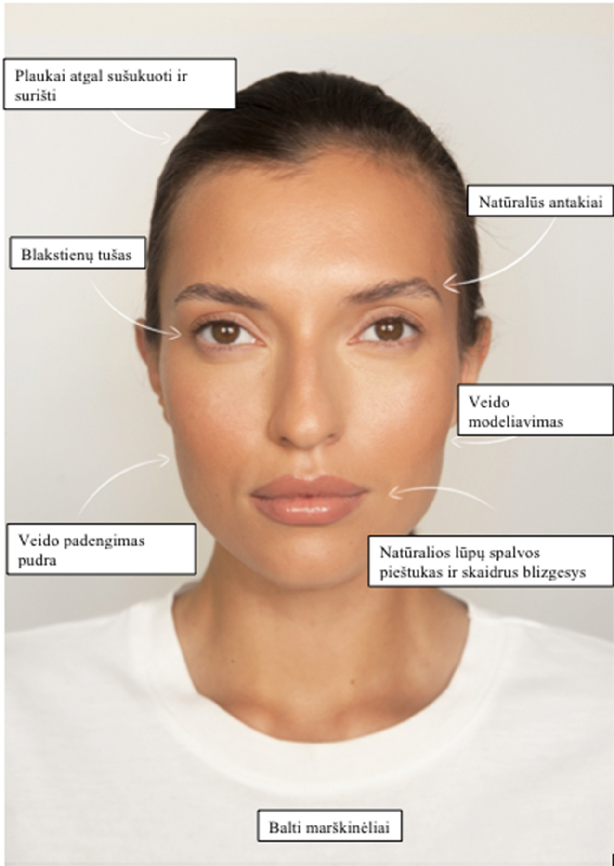
natural lip color pencil and clear gloss
White T-shirt
hair slicked back and tied
face powder
facial modeling

natural eyebrows
Mascara

