LITHUANIAN OPEN CHAMPIONSHIP (LAČ)
for beauty professionals
"KAUNAS BEAUTY 2024"
24-25 February 2024

EYELASH EXTENSION COMPETITIONS

JUNIOR CATEGORY (master with up to 2 (two) years' experience)
- Classic eyelash extensions (time allowed for the competition -2 hours)
- "Volume 3D-6D extensions (time allowed for the competition - 3 hours)
- Eyelash Lamination (time allowed for the competition - 1 hour 30 minutes)

MASTER CATEGORY (masters with 2 (two) years of experience or more or who have at least one photo competition win)
- Classic eyelash extensions (time allowed for the competition - 1 hour 40 minutes)
- "Volume 3D-6D extensions (time allowed for the competition - 2 hours 30 minutes)
- Eyelash Lamination (time allowed for the competition - 1 hour 20 minutes)

EXPERT CATEGORY (trainers, multiple winners of photo competitions or live championships)
- Classic eyelash extensions (time allowed for the competition - 1 hour 40 minutes)
- "Volume 3D-6D extensions (time allowed for the competition - 2 hours 30 minutes)
- Eyelash Lamination (time allowed for the competition - 1 hour 10 minutes)

GENERAL RULES FOR EYELASH EXTENSION COMPETITIONS

- When registering for the relevant category, competitors must attach a copy of their professional diploma and send it with their entry form.
- Competitors shall take out their bed numbers 20 minutes before the start of the competition and must be at their workstations 15 minutes before the start time.
- Competitors are not allowed to exchange bed numbers.
- When you pull out your bed number, you have to be at the bed and wait for the chairman of the jury to look at it, assess the lashes and check that the bed numbers match the names of the participants.
- Only after the jury chairman has checked and verified that the participant is working according to the workstation (bed) number, the participant may prepare his/her eyelashes for eyelash extensions (wash with shampoo, isolate the lower eyelashes, degrease, draw a diagram).
- Tools that are not needed by the master are placed under the table and the work area must be kept tidy.
- When the masters have finished, they have 5 minutes to tidy up their work area, prepare their model for the judges' inspection and leave the championship area. It is forbidden to leave any tools or objects on the work table.
- During the competition, the foreman must wear a logo-free working gown, or, in the absence of a working gown, he may wear a black or white shirt and have his hair neatly tied up.
- Models entering the competition must be free of eyelash extensions or laminated eyelashes, and without any permanent or cosmetic make-up on the eye area.
- The model's outfit must be neat and tidy: black trousers and a white T-shirt. Shiny or any other accessories are not allowed. Do not wear contact lenses (or have a container to put them in);
- The model may undergo light facial contouring. The lips are painted with a colourless or nude lipstick. Hair is tied in a ponytail or a ponytail (not falling on the model's eyes)
- Only fully completed works are submitted for judging.
- The models must come to the judging area and appear before each judge to be judged.
- For infringements of the competition rules and failure to comply with the instructions, participants will be subject to penalties in accordance with the applicable penalty table.
- Penalty points - the minimum penalty is 1 penalty point per infringement
- Auxiliaries - the use of any auxiliary aids will be penalised if it is not permitted.
- When registering, the participant must provide a good quality copy or photograph of their first diploma. This will ensure transparent and fair participation and category selection. False reporting of work experience will result in disqualification.
- News in the eyelash extensions game from 2024:
  - You MUST bring your own lamp during the competition.
  - A humidifier is recommended.
  - standard workstations will be installed on the tender site.
  - the organisers are not responsible for the workplace (bed), table, chairs, lighting or other (un)facilities.

CLASSIC EYELASH EXTENSIONS
Time: Junior 2 hours; Master 1 hour. 40 min.; Expert 1 hour. 40 min
Live model (girl; aged 16 and over)
The classic eyelash extension technique is when one false eyelash is attached to one natural eyelash. Available thicknesses 0.07/ 0.08/ 0.10/ 0.12.) At least two strands shall be used.

CRITERIA | REQUIREMENTS | BALAI
General appearance of the model | The overall look, the correct choice of lash colour and the choice of eyelash extensions are evaluated.  Black lashes are recommended for cold models. For the warm type, brown lashes are recommended.  Facial harmony is maintained. | 5 points
Simulations | The complexity of the modelling is assessed. Transition of long lines. Eyelash layering is required! | 5 points
Adhesion between eyelashes | The eyelashes must not be glued together. Classically glued lashes must be separated and well adhered to the natural, single lash.  The lower and upper eyelashes must not be glued together.  The judge's tweezers must not get stuck between the eyelashes. If this happens, there is a grip. It is recommended to check the eyelashes thoroughly for adhesions after the work has been completed and to correct them if found. | 5 points
Direction for eyelash extensions | All eyelashes must be applied parallel to each other. No crossing of eyelashes is allowed. Allowed directions: classic (perpendicular to the eyelid). | 5 points
Symmetry of both eyes | Both eyes must be modelled equally. The number of eyelashes must be the same in both eyes. | 5 points
Inner corners | 100% coverage, direction perpendicular to the envelope. | 5 points
External corners | 100% coverage, direction perpendicular to the envelope. | 5 points
Eyelash filling | 100% coverage of all lashes. | 5 points
Distance from the envelope | Distance from the envelope 0,2 to 0,5 mm | 5 points
Cleanliness at work | Eyelash extensions must be neat and clean. There must be no gel residue on the pads, no pen marks on the skin, no glue residue on the skin and no excess glue on the lashes.  No cosmetic residue or other impurities in the eye area or eyes. | 5 points
Additional penalty points | The workplace must be tidy, you must comply with the criteria and you must not cheat, otherwise your points will be deducted in the following order :  - Contact lenses with the model (-1 point)  - Workstation left in disarray (-1 point)  - Disobedience to stop (-1 point)  - Late (-1 point)  - Model's face covered in eyelashes -1 point. | -5 points
Total amount |  | 50 points

VOLUME 3D-6D EXTENSIONS
Time: Junior 3 hours; Master 2 hours. Master 2 hrs. 2 hrs. 30 min./ Expert 2 hrs. 30 min
Live model (girl; aged 16 and over)

"Volume 3D-6D extensions are volume eyelash extensions. In this category, eyelash extensions can only be done in Volume 3-6D and in a solid line, looks such as "Kim k, Kylie style, wet lashes" etc. are not included in this category. The volume technique is chosen by the artist (if the chosen technique is 5D, then the extensions must be done only in 5D). B, C, J, CC, D, L, M, V, U, L+, LC, LD, etc.). At least two nodes shall be used for modelling. Eyelash extensions must be applied using 0.03, 0.05, 0.06,
0.07 lashes. In this competition we will assess your modelling skills and technique.

CRITERIA | REQUIREMENTS | BALAI
General appearance of the model | The overall look, the correct choice of lash colour and the choice of eyelash extensions are assessed.  Black lashes are recommended for cold models. For the warm type, brown lashes are recommended.  The density of the Volume lashes is well chosen, maintaining harmony on the face. | 5 points
Simulations | The complexity of the modelling is assessed. Transition of long lines. Eyelash layering is required! | 5 points
adhesion between the droplets | The eyelashes must not be glued together. The volume clump must be glued to one natural lash and not twisted with the other lashes.  The judge's tweezers must not get stuck between the eyelashes. If this happens, there is a grip. It is recommended that you carefully check your own eyelashes for any adhesions when you have finished your work and correct them if you find them. | 5 points
Direction for eyelash extensions | Classical direction (perpendicular to the envelope) is allowed. | 5 points
Inner corners | 100% coverage. | 5 points
External corners | 100% coverage. | 5 points
Eyelash filling | 100% coverage of all lashes. | 5 points
Distance from the envelope | Distance from the envelope 0.2 to 0.5mm. | 5 points
Cleanliness at work | Eyelash extensions must be neat and clean. There must be no gel residue on the pads, no pen marks on the skin, no glue residue on the skin and no excess glue on the lashes.  No cosmetic residue or other impurities in the eye area or eyes. | 5 points
Volume staple | Regular Volume tuft with a regular round leg.  The stamens must be uniform. The use of ready-made staples is forbidden! | 5 points
Penalty points | The workplace must be tidy, you must comply with the criteria and not cheat, otherwise points will be deducted in the following order  - Contact lenses with the model (-1 point)  - Workstation left in disarray (-1 point)  - Disobedience to stop (-1 point)  - Late (-1 point)  - Model's face covered with Volume tufts -1 point. | -5 points
Total amount |  | 50 points

NATURAL EYELASH LAMINATION
Time: Junior 1 hr. 30 min.; Master 1 h. 20 min / Expert 1 h. 10 min.
Live model (girl; aged 16 and over)

CRITERIA | REQUIREMENTS | BALAI
General appearance of the model | This is the judge's overall impression of the work done.  Possible assessment  when the model is standing or sitting. Attention is paid to all the criteria at once: the right lash angle, the symmetry of both eyes. | 5 points
Natural eyelash shaping | The curve of the natural eyelashes must be chosen so that it does not rest on the upper eyelid. Available silicone cap sizes S, M, M1, M2, L, XL.  Selected according to the length of the natural eyelashes. The image must be the same for both eyes. The shape of the curler must be chosen according to the characteristics of the model's eye: deep eyes, drooping eyelid, lowered outer corners of the eye. | 5 points
Lifting natural lashes from the root | Must be uniform on all eyelash layers. The application technique shall be chosen according to the shape of the model's eyes. The eyelash must not be kinked in the root area | 5 points
Eyelashes in one plane | For natural eyelashes, all the layers must be in a single line, with an even eyelash placement. The tips are not broken. | 5 points
Proper directions for natural eyelashes | Natural eyelashes must be curled in the right direction, without crossing or visible gaps. The entire length of the eyelash must be free of any kink. | 5 points
Natural eyelash colouring | Natural eyelashes are coloured with black-blue, black, brown, grey, depending on the model's skin and hair type.  There must be an even distribution of paint. | 5 points
Eyelash fluffiness, cleanliness, proper removal of dye residues | The model must appear before the judges with fluffy, clean eyelashes after the natural eyelash lamination procedure, with no excess dye residue, and the colour of the dye must not remain on the skin of the eyelid.  The concentrate applied at the end (No. 3, etc.) must not weigh down and stick to the lashes. | 5 points
Symmetry of both eyes | The natural eyelashes (of both eyes) must be luminised equally. | 5 points
Proper lifting of internal corners | Proper eyelash lift on both eyes, symmetry, overall look. All lashes must be luminous and lifted from the root. | 5 points
Proper lifting of external corners | Proper eyelash lift on both eyes, symmetry, overall look. All lashes must be luminous and lifted from the root. | 5 points
Penalty points | Red eyes, tearing. Redness of the eyes indicates that the work has not been done properly. The pads covering the lower eyelashes were glued too close. Alternatively, the products may have got into the eye. (- 1 point)  Contact lenses with the model (-1 point)  Workstation left in disarray (-1 point)  Disobedience to stop (-1 point) Late (-1 point) | - 5 points
Total amount |  | 50 points

RECOMMENDATIONS:
- Stick disposable pads further away from the eyelid to avoid red, irritated eyes OR avoid them altogether.
- Available in sizes S, M, M1, M2, L, XL. To be chosen according to the length of the natural eyelashes.
- Make sure there is no paint residue before handing the model over to the judges. Clean the eyelid properly so that it is not sticky with glue.
- Do not overuse concentrates (No 3, etc.). This will save the lashes from being weighed down and sticking together.

ADDITIONAL POINTS

Eyelash inclination | - Downward and straight lashes  - Uneven curve of natural eyelashes in areas.  - Lashes with a natural curl (with their own curl) | 2  1  0
Shape of the eye | - Deep eyes  - Droopy eyelid (when the eyelid lies on the lash line)  - Heavy envelope | 2  2  1
Condition of natural eyelashes | - Curled natural lashes  - Eyelash tips tend to curl/coil | 1  1

EXAMPLES

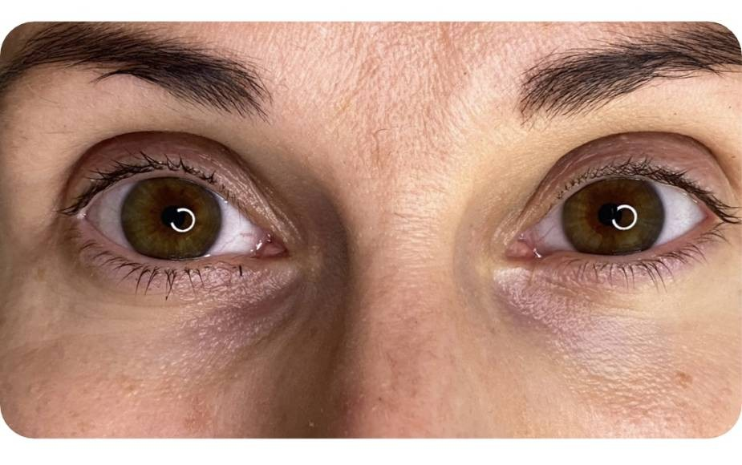 | Deep eyes
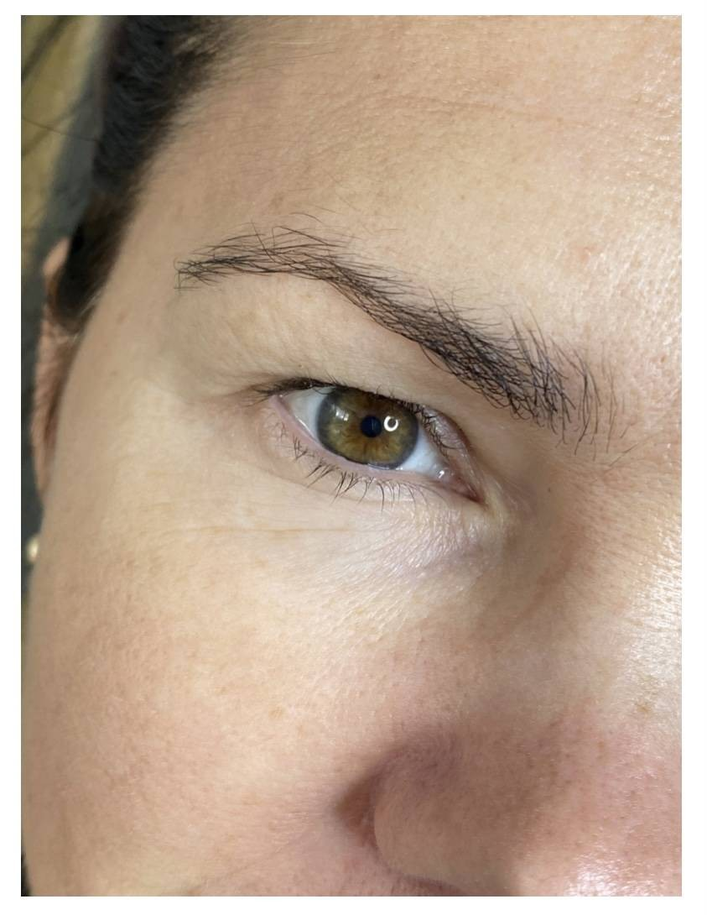 | Dropped envelope
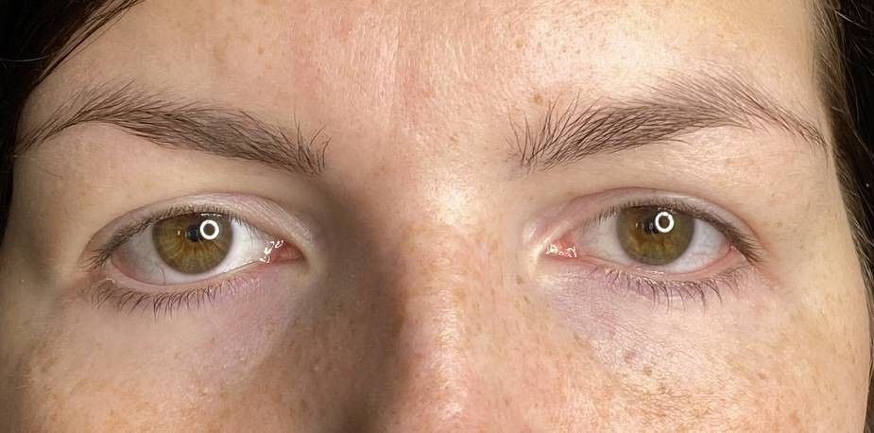 | Outer corner of the eye sad

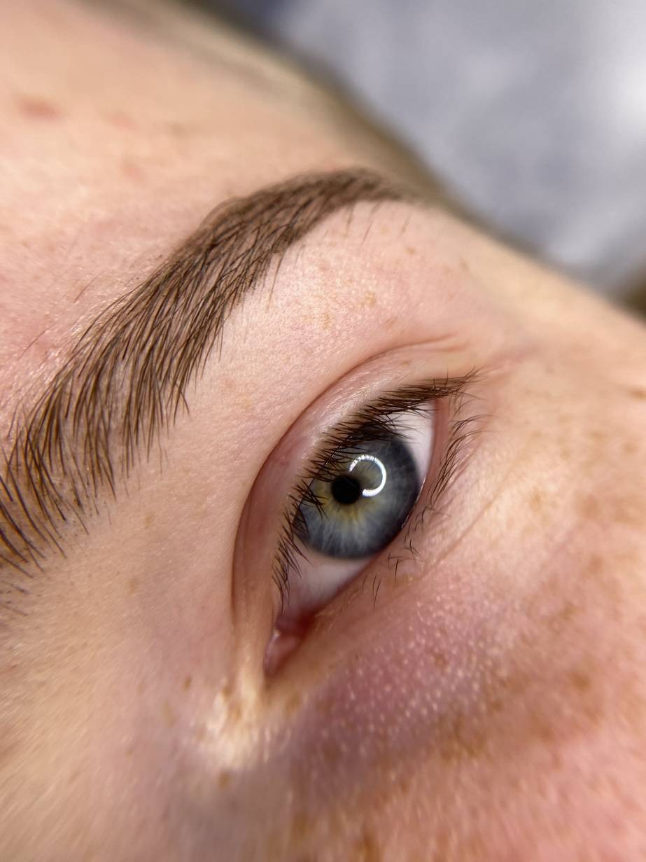 | Downward-growing eyelashes
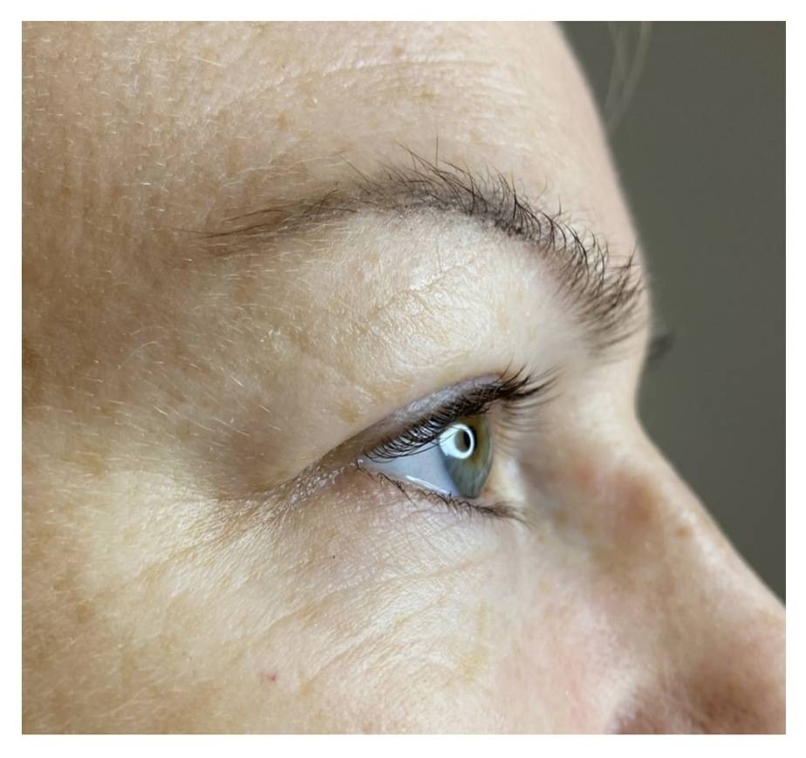 | Heavy envelope

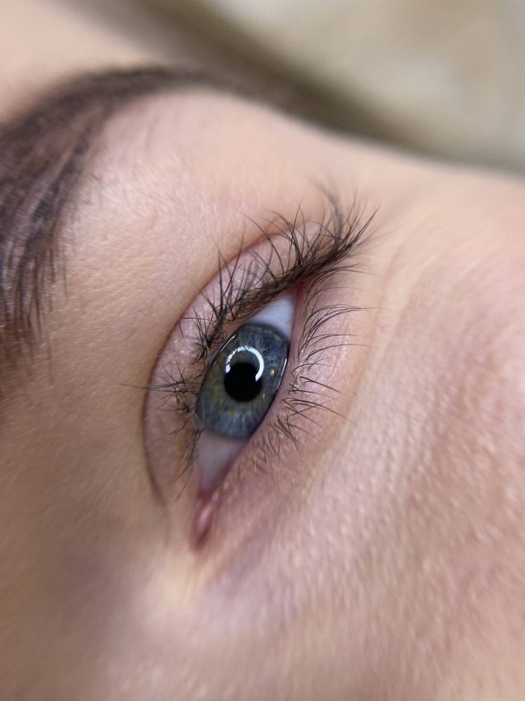 | "Rolled" eyelashes

