KIGSA GRAND PRIX CUP 2026 PHOTO COMPETITION FOR EYELASH MASTERS

PHOTO CONTEST TERMS:

• FOR EYELASH EXTENSION NOMINATIONS. Contestants must submit 4 photos of the work process for the selected eyelash extension nomination:
- BEFORE THE PROCEDURE
1. The model is looking straight at the camera with her full face at a distance of 20-30 cm.

- AFTER THE PROCEDURE
2. The model is looking straight at the camera with her full face at a distance of 20-30 cm.
3. One eye is looking up.
4. The model is 20 cm away with closed eyes, with eye pads and a modeling scheme drawn. The photo is taken while standing above the head, the model is lying down.
* Each photo will be evaluated according to different criteria, so if you do not submit all of them, it will not be possible to collect the maximum number of points.
5. A close-up photo of the left eye open (Recommended with a lens or macro mode) so that the entire lash line, outer and inner corners are visible.
6. Close-up photo of the right eye open (Recommended with a lens or macro mode) to see the entire lash line, outer and inner corners.

• FOR THE EYELASH LAMINATION NOMINATION. Contestants for the eyelash lamination nomination must submit 10 photos of the work process.
• - BEFORE THE PROCEDURE
1. The model looks directly at the camera with her full face at a distance of 20-30 cm.
2. The model sits or stands with her eyes open from the side so that the curve of the natural eyelashes can be seen.
3. Photos with a MACRO lens, each eye separately, the angle is straight.

-PROCEDURE
3. Lifting / tensioning the eyelashes of both eyes on the curler. The size of the curler must also be visible.

- AFTER THE PROCEDURE
4. The model looks directly at the camera with her full face at a distance of 20-30 cm.
5. Photos with a MACRO lens, each eye separately, a straight angle.
* Each photo will be evaluated according to different criteria, so if you do not provide all of them, it will not be possible to collect the maximum number of points.
7. Close-up video of the left open eye (Recommended with a lens or macro mode) so that the entire lash line, outer and inner corners are visible.
8. Close-up video of the right open eye (Recommended with a lens or macro mode) so that the entire lash line, outer and inner corners are visible.

• Photo montages (collages) made from 2 or more photos are not allowed!
• THE MODEL MUST be wearing a white T-shirt without any logos, with hair tied in a bun or ponytail.
• Photos participating in the contest must be new, specially photographed for this contest, i.e. Photos may not be published publicly before the start of the competition and throughout the competition, until the results are officially announced.

• It is forbidden to use logos or other inscriptions on the submitted photos.
- • If this condition of the competition is violated - the registration will be canceled and the participation fee will not be refunded!
- • Requirements for the photo:
- 1. The photo must be in digital format, as high quality as possible.
- 2. Good resolution so that the details are clearly visible.
- 3. The photo can be minimally edited in Photoshop or another editing program, but it cannot be changed, corrected or drawn in the eyelash extension area. *if the photo is edited, an unretouched photo must be attached, and the note “photo retouched” must be added to the edited one
- 4. The background of the photos is recommended to be white or gray.
- • The organizers of the competition reserve the right to use the photos in the public domain at their discretion, without separate coordination with the participants of the photo competition and models.
- • Photos should be sent together with the completed registration form to the e-mail email info@kigsa.lt by March 1, 2026.

- PHOTO CONTEST MASTER CATEGORIES IN WHICH YOU CAN COMPETE:

- • JUNIOR - A master working for up to 2 years.
- • MASTER- A master working for 2 years or with no more than one photo contest win.
- • EXPERT - with work experience, awards, conducting training or courses.
- *Participants must submit a copy of their first DIPLOMA when registering as proof that they work in the eyelash field and can compete in a specific category.

- NOMINATIONS

- CLASSICAL EYELASH EXTENSION - Eyelash extension, when one artificial eyelash is extended onto one natural eyelash. The overall harmony of the face and maximum naturalness are maintained according to the following rules:
- • Eyelash extensions must be performed using 0.07, 0.08, 0.10 or 0.12 thick eyelashes.
- • Eyelash extension colors – black or brown (matching the model’s skin and hair color).
- • The following curls can be used during the extension: B, C, J, CC, D, L, M, V, U, L+, LC, LD, etc.).
- • It is recommended to choose colorless glue for brown eyelashes.
- • At least two curls of different shapes are used for modeling.
- • Eyelash layering is required.
- • The selected lengths can correspond to the length of the natural eyelashes or be no more than 2mm longer.
- • The base of the face can be lightly contoured, with rosy cheeks, filled in eyebrows, and lips highlighted with colorless paint. However, the model cannot have permanent or cosmetic makeup in the eye area.
- • Glitter or any other accessories are prohibited.
- • Eyelash extensions must be neat and clean. The model's eyes must not be red after the procedure. There must be no visible gel residue from the pads, pen marks on the skin, no glue residue on the skin, as well as their excess or whitening on the eyelashes. No cosmetic residue or other dirt in the eye area or in the eyes.
------------------------------------------------------------------------------------------------------------------------------------------------------------------------------

VOLUME 3-6 D EYELASH EXTENSIONS - Eyelash extensions, during which the appropriate modeling is selected, appropriate curves, lengths and density are applied, taking into account the shape of the model's eyes and face. The overall harmony of the face is maintained according to the following rules:

• Eyelash extensions must be performed using 0.03, 0.05, 0.06 or 0.07 thick eyelashes. The volume technique is chosen by the master (if the chosen technique is 5D, then the extension must be performed only in 5D).
• The following curves can be used during the extension: B, C, J, CC, D, L, M, V, U, L+, LC, LD, etc.).
• Extensions of this category are performed in a solid line, such images as: “Kim k, Kylie style, wet lashes” etc. are not included in this category.
• It is forbidden to use ready-made tufts.
• The colors of the eyelash extensions are black or brown (matching the model's skin and hair color).
• It is recommended to choose colorless glue for brown eyelashes.
• At least two forms of curls are used for modeling.
• Eyelash layering is mandatory.
• The selected lengths can correspond to the length of the natural eyelash or be no more than 2mm longer.
• The base of the face can be lightly contoured, with rosy cheeks, painted eyebrows, and lips highlighted with colorless paint. However, the model cannot have permanent or cosmetic makeup in the eye area.
• Shiny or any other accessories are prohibited.
• Eyelash extensions must be neat and clean. The model's eyes must not be red after the procedure. There should be no visible gel residue from the pads, pen marks on the skin, no glue residue on the skin, as well as their excess or whitening on the eyelashes. No cosmetic residue or other dirt in the eye area or in the eyes.
• Eyelash filling must be done 100 percent (all natural eyelashes are covered both in the inner and outer corners of the eyelid, as well as in the central part).
• The allowed distance from the eyelid is 0.2 - 0.4 mm (if 0.4 mm is selected, then the same distance of 0.4 mm must be maintained throughout the entire eye area).
• Extensions are performed on a live model!

•EYELASH LAMINATION - taking into account the shape of the model's eyes and face, the appropriate eyelash curl is selected.
• The general appearance of the model. Attention is paid to all criteria at the same time, the appropriate eyelash curl, the symmetry of both eyes.
• The curl of natural eyelashes must be performed so as not to rest on the upper eyelid.
• The shape of the curler must be selected according to the characteristics of the model's eye: deep-set eyes, drooping eyelid, lowered outer corners of the eye.
• The appearance of both eyes must be the same. Natural eyelashes - laminated equally.
• Proper eyelash lift - all eyelashes are laminated and raised from the roots, especially in the outer and inner corners. The eyelash in the root area must not be bent
• Eyelash curl in one plane. All layers of natural eyelashes must be in one line, the arrangement of eyelashes is even. The tips are not broken.
• Natural eyelashes must be laminated in the right direction, evenly arranged, without crossings, visible gaps.
• All layers of natural eyelashes must be in one line. There must be no wavy eyelashes, broken tips.
• The application technique of the products is selected according to the shape of the model's eyes.
• Natural eyelashes are dyed with black-blue, black, brown or gray dyes, depending on the skin and hair type of the model. The dye distribution must be even.
EXAMPLES

- 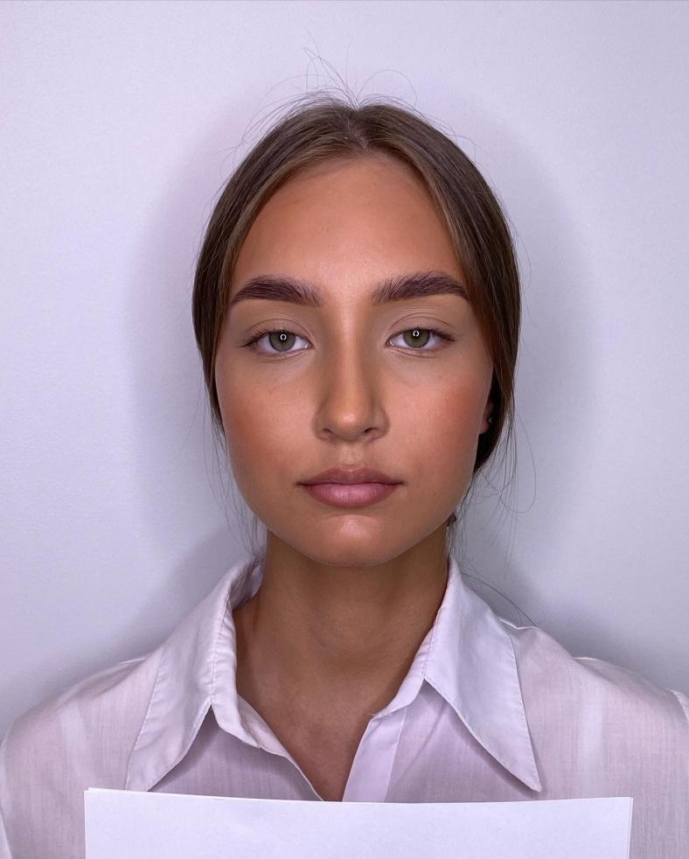 | - 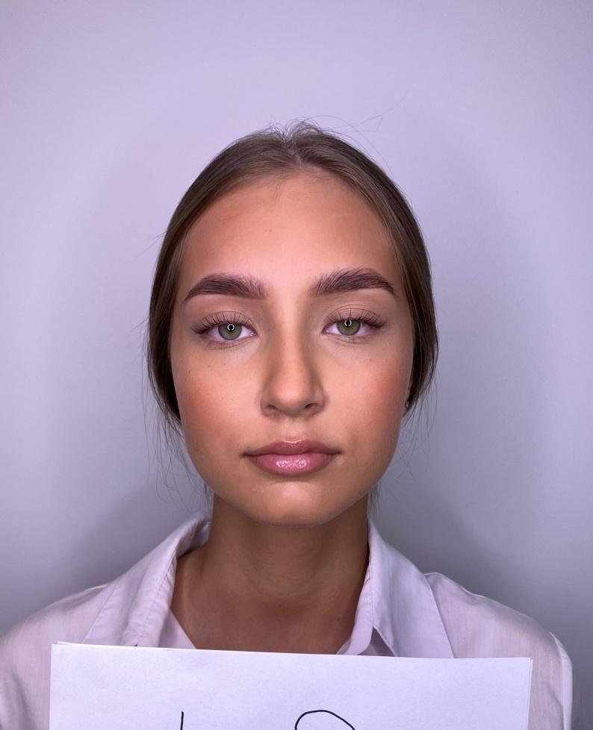
- 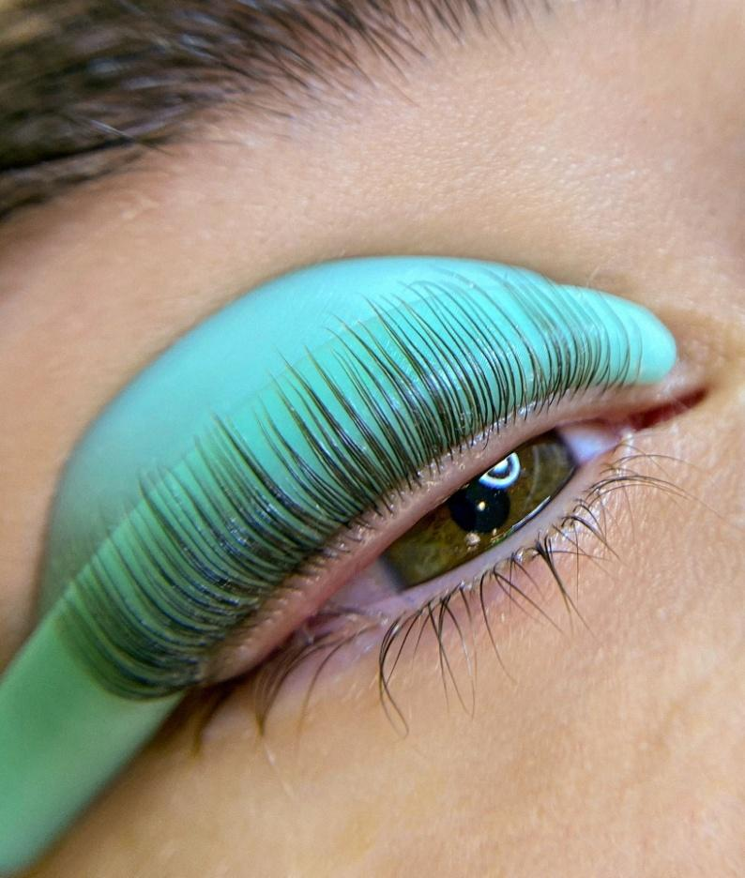 | - 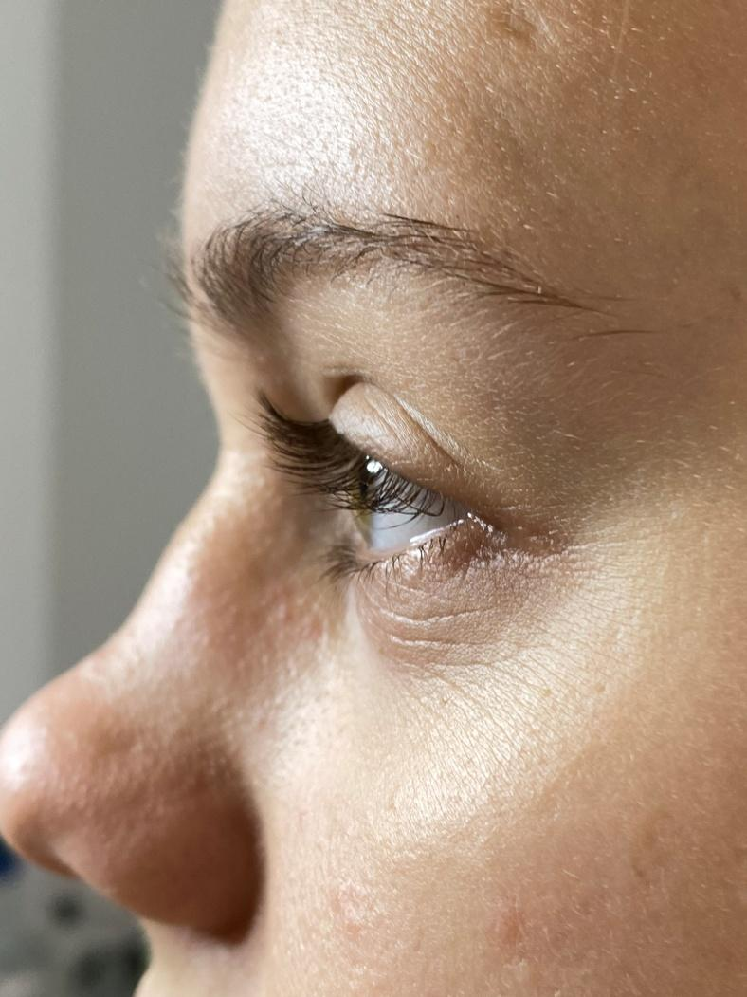
- 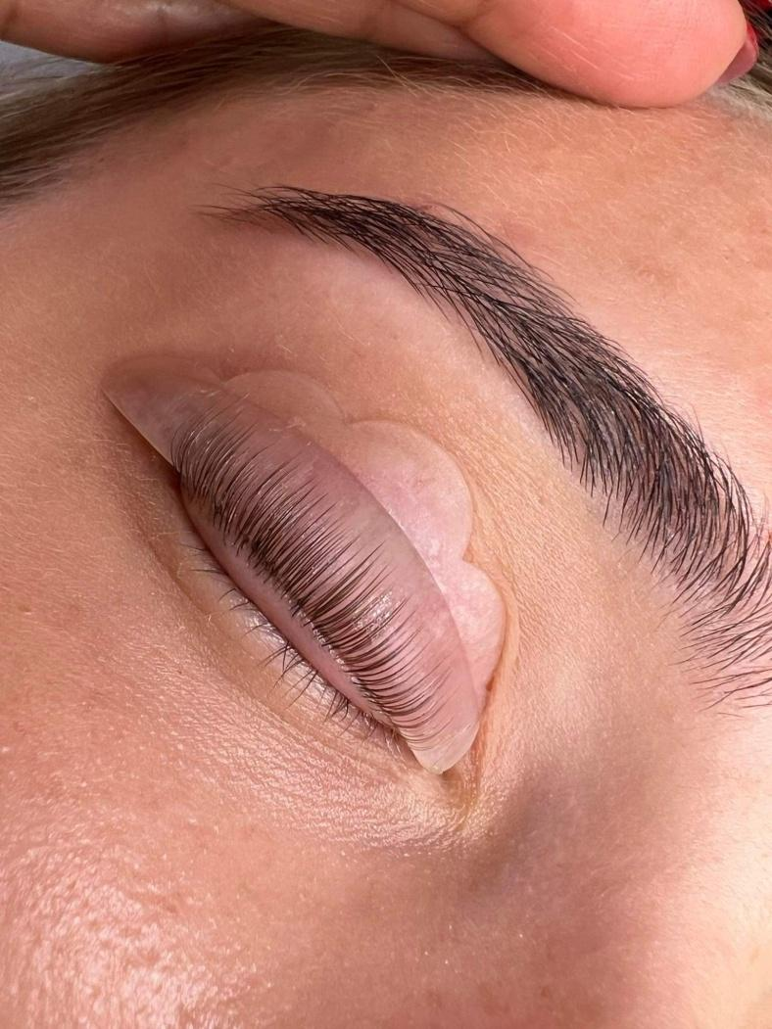 | - 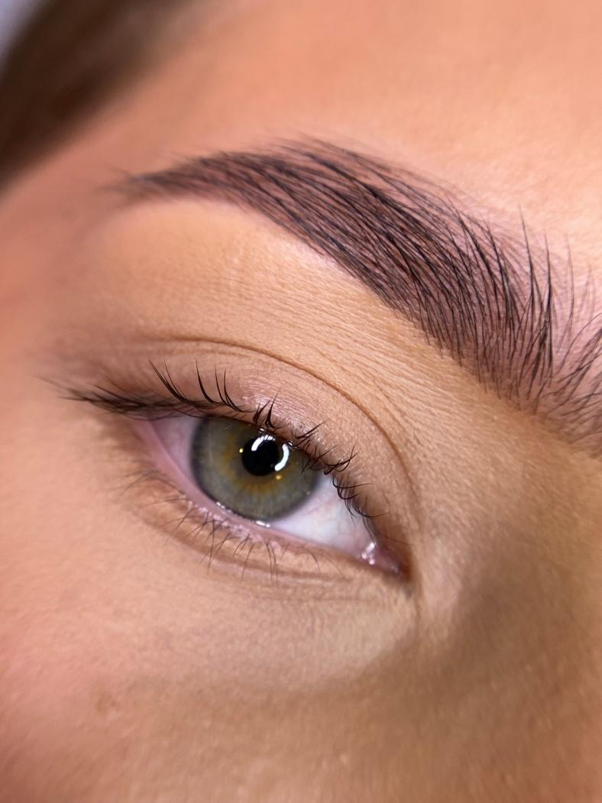
- 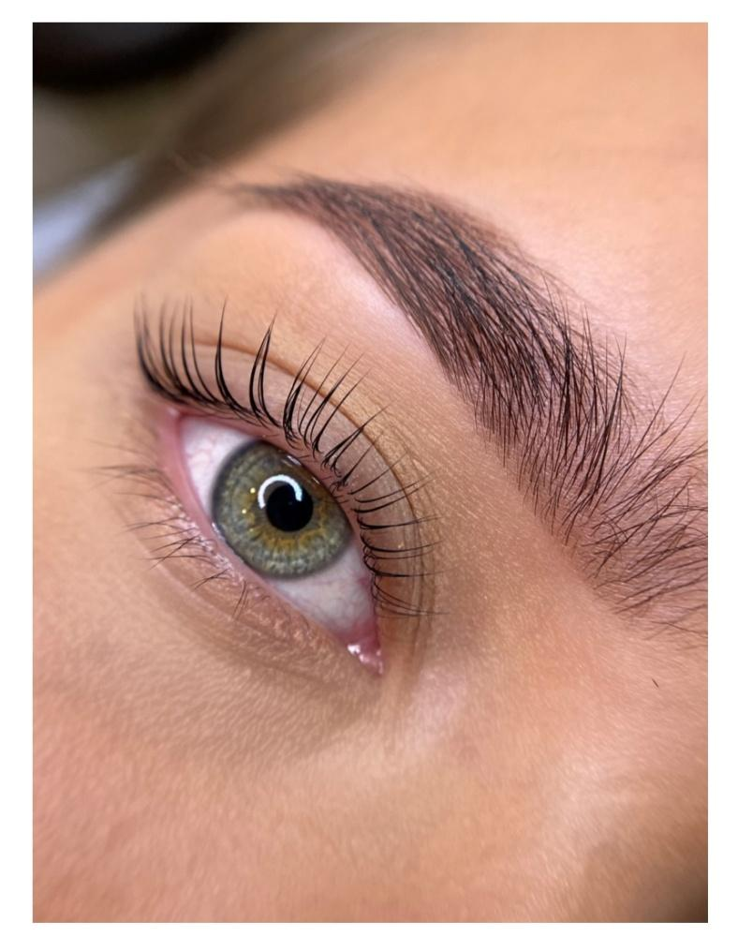
• The concentrate applied at the end (3nr., etc.) should not weigh down or stick the eyelashes.
• The base of the face can be lightly contoured, with rosy cheeks, painted eyebrows, and lips highlighted with colorless paint. However, the model cannot have long-term or cosmetic makeup in the eye area.
• The model, after the natural eyelash lamination procedure, must have fluffy, clean eyelashes, without excess paint residue, and the paint color must not remain on the eyelid skin.
• Eyelash lamination is performed on a live model!

EVALUATION AND AWARDS

• The evaluation committee is made up of professional, highly competent foreign masters with international recognition.
• After summing up the votes of the committee, the 1st-3rd place winners from each nomination and category of the competition will be awarded medals, diplomas, and sponsor gifts.
• Diplomas will be awarded to the 4th-5th place winners. All participants of the competition will receive participant diplomas.

